EFFICIENT ALGORITHMS ON THE HYPERSTAR NETWORK
ABDEL-ELAH AL-AYYOUB and KHALED DAY
Parallel Algorithm and Applications, Vol. 14, 1999, pp79-88
Abstract
This paper presents efficient node-ranking schemes for the hyperstar network. These schemes are then used to develop various parallel algorithms. The proposed schemes are then compared with their mesh and hypercube counterparts.
- Introduction

A number of product networks have been in the literature. Some examples as following:

Hyper-Petersen network
Mesh-connected-trees
Product-shuffle network
Hyper-deBruijn network
Star-cube network
Hyperstar network

Compared to the hypercube, the hyperstar network scales better and use a smaller number of links. Also, the broadcasting cost incurred by the hyperstar is lower. The hyperstar has more potential than its factor graph in terms of efficient embedding of topologies such as hypercubes and meshes.
- The HyperStar Network
The k-dimensional hyperstar, 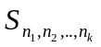 is a product network formed by the graph product of k star graphs, 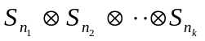.
Hyperstar is a Cayley graph and hence is vertex symmetric.
Degree 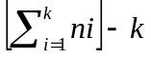, diameter 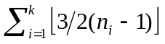 and average diameter 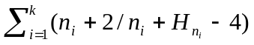, where 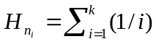
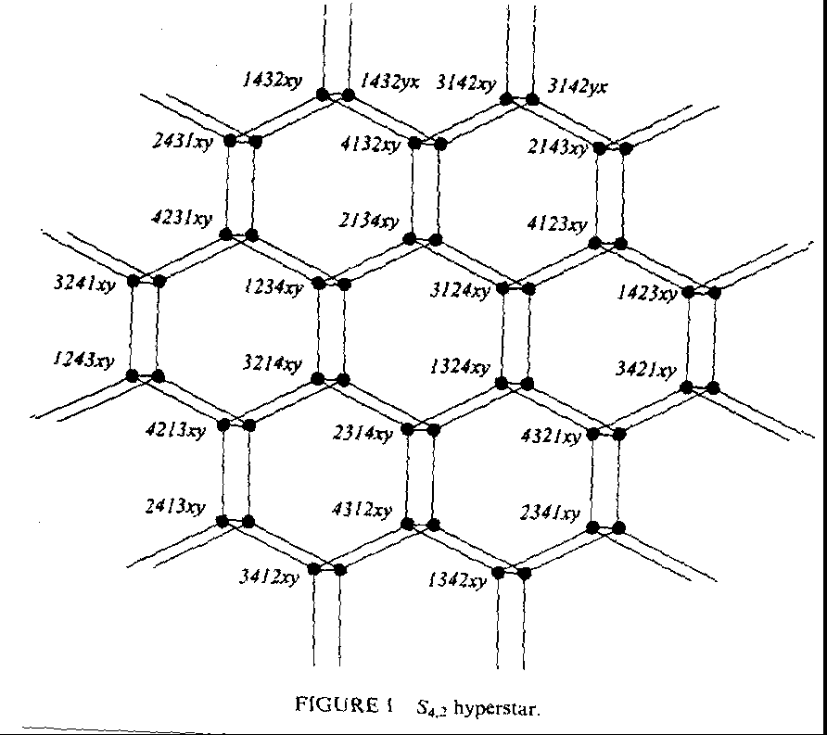
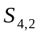48 degree-4 nodes distributed at a diameter of 5.
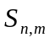can be decomposed into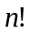node-disjoint -stars or into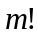node-disjoint -stars
For every fixed permutation of the first symbols, an -stars can be generated by varying the last symbols.
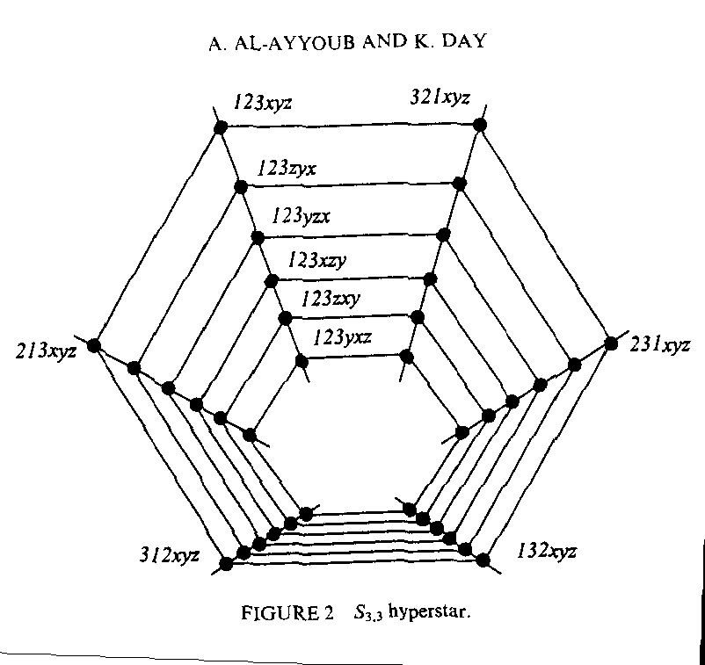
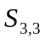shown in figure embeds six 3-stars, nine 2-cubes, one 66 wraparound mesh, and six rings of length 6.
- Node-Ranking Schemes for the Hyperstar Network
- Rectangular Grid Views
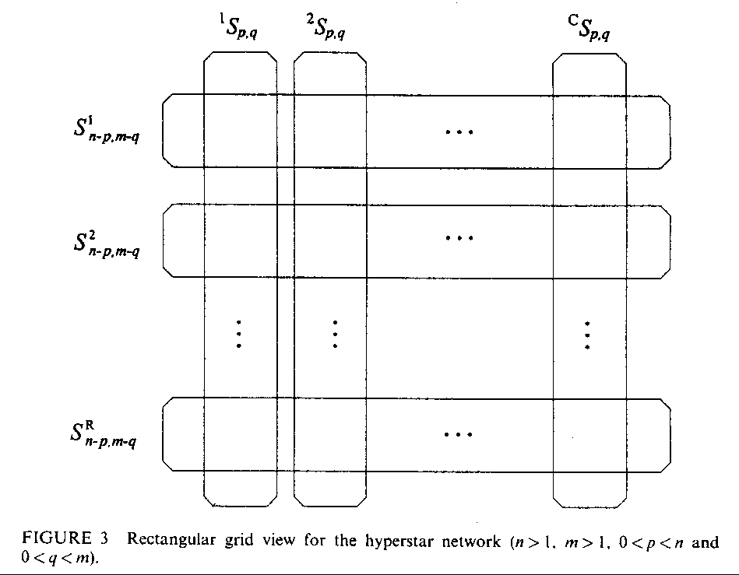
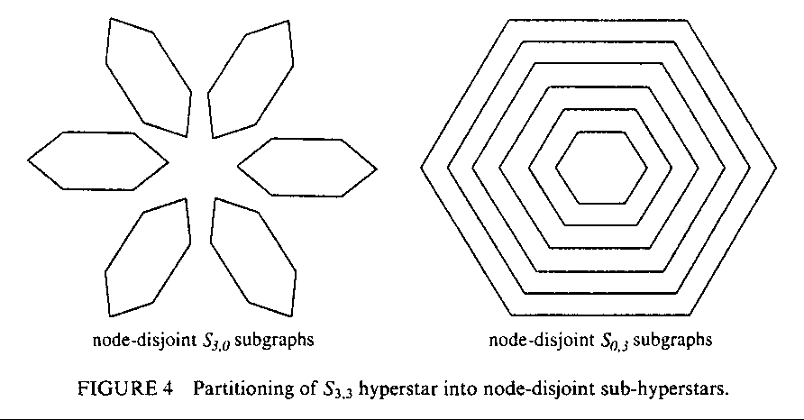
- Pipeline Views
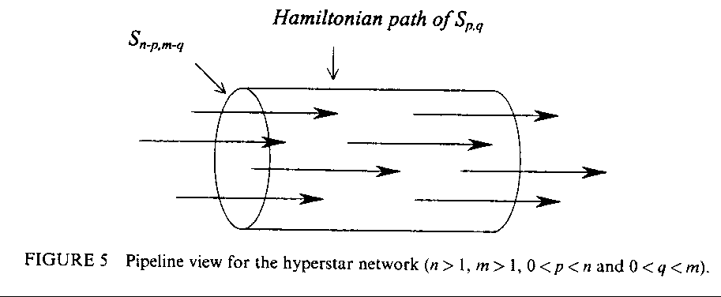
- Reconfigurable Wraparound Mesh Views
- Perfomance Estimation Models
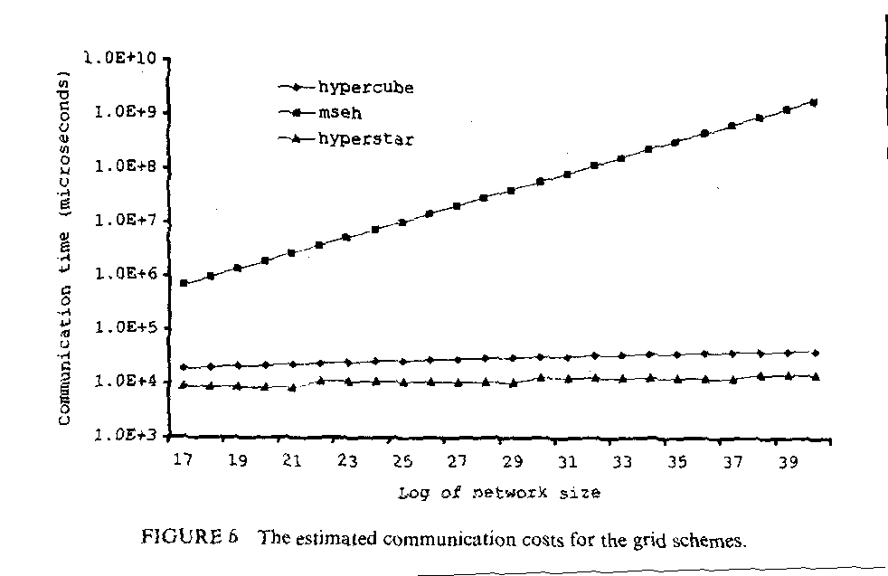

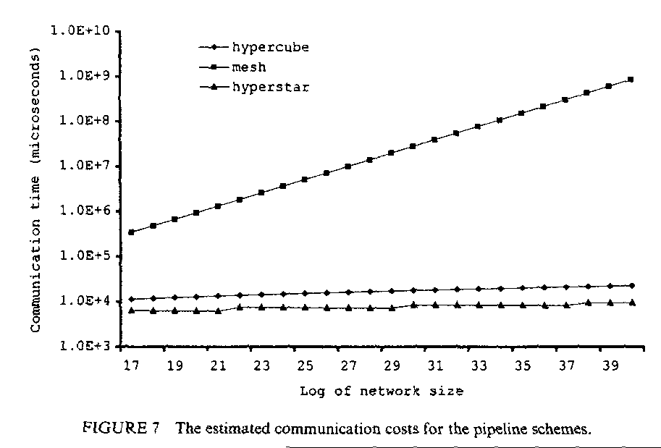
- Conclusion
Created by : Jenn-Dar Chang
Date : Dec. 10, 1999

